New Docebo Course Player Interface

Docebo will be switching to a new Course player interface in late 2024. This change is focused on increasing the level of compliance of the Docebo LMS with the Web Content Accessibility Guidelines. While the new design includes some functional enhancements, the redesign of the course page is mostly about accessibility. The biggest improvement coming with the new interface for Docebo is what learners will see while attending eLearning courses in the LMS. The comparison below uses screenshots taken from the “Evaluations and Certification Training” course that many of you participated in a few years ago. The screenshots show the interface differences between the current course player and the new course player for this course.

Current course player:
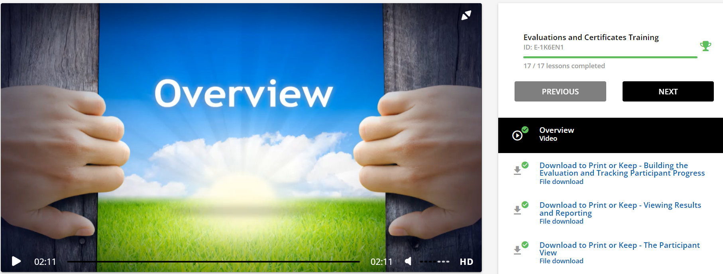

New course player:
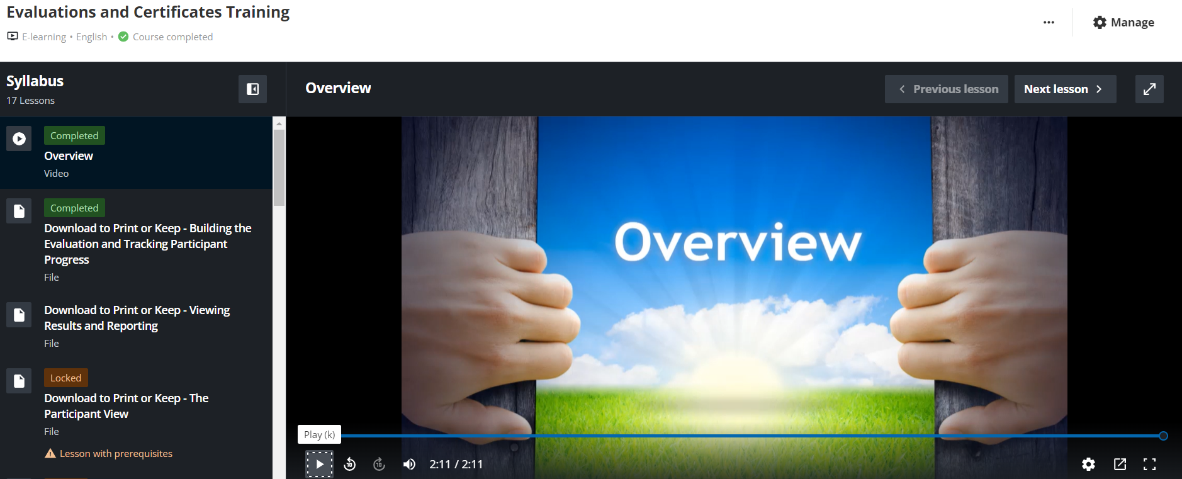

Please note the “Table of Contents” is now referred to as the Syllabus. Just like with the “Table of Contents”, this information can be closed or re-opened by clicking the small icon towards the right of the syllabus header.
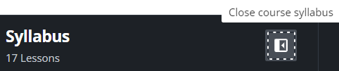

The course player page for courses has been completely re-vamped with the following enhancements:
- Course syllabus: The new area showing the course content is an expandable panel allowing learners to navigate the course lessons, and that can be displayed or hidden with a click.
- Consistent player experience: The new course player has been designed to provide a consistent experience for all types of training materials. Navigation elements and functionalities do not change position or aspect but simply adapt them according to the type of training material.
- Theater mode: To provide a real immersive user experience, the new player includes the Theater Mode view, which allows learners to expand the player and focus only on the content by hiding the platform header and the course widgets while keeping the course syllabus and the navigation bar visible.

The course page has been redesigned to highlight the course training material (lessons). In addition, course widgets are available from a dedicated menu organized in tabs. The layout of the page is composed of three main areas:
Course title bar: This area shows the course title, the course type, the course language, the learners' progress in the course, and the action buttons allowing learners to perform the actions configured for the course.
Player area: The area most impacted by the revamp. It includes the course syllabus expandable panel, the lessons navigation bar, the player, and the description of the lesson.
Widgets: The course widgets are grouped in a dedicated area under the player area, and are organized in tabs. All the widgets are labeled with headings. To provide a good experience to keyboard-only users, the keyboard focus allows them to move to the title of the widget selected.

- Course details widget: This new widget shows the course details defined in the Course Information section of the Details area of the course Properties tab (except for the course description).

Learner Resources
Docebo also developed a resource page for learners needing assistance navigating the new course page. This resource can be shared with learners and is found here:
Learner Guide for the New Course Page

